Enhancing Tanglish Sentiment Analysis through Hybrid NLP: Rule-Based Lexicons and Indic-BERT Integration
IBM APPLICATION COURSE PROJECT REPORT
(216CSE4301)
Submitted by

RAJESH KANNA R – 99220041074
SAKTHI SANJAY S – 99220041079
VIJAYAKUMAR M – 99220040774
KESANI ROHITH – 99220040574

in partial fulfillment for the award of the degree
of
BACHELOR OF TECHNOLOGY
IN

COMPUTER SCIENCE AND ENGINEERING



SCHOOL OF COMPUTING
COMPUTER SCIENCE AND ENGINEERING
KALASALINGAM ACADEMY OF RESEARCH
AND EDUCATION
KRISHNANKOIL 626 126

DECEMBER 2025

DECLARATION

We affirm that the project work titled “Enhancing Tanglish Sentiment Analysis through Hybrid NLP: Rule-Based Lexicons and Indic-BERT Integration” being submitted in partial fulfillment for the award of the degree of Bachelor of Technology in Computer Science and Engineering is the original work carried out by us. It has not formed part of any other project work submitted for the award of any degree or diploma, either in this or any other University.
RAJESH KANNA R
99220041074

SAKTHI SANJAY S 99220041079

VIJAYAKUMAR M
99220040774

KESANI ROHIT 99220040574

This is to certify that the above statement made by the candidate is correct to the best of my knowledge.
Date:

Signature of supervisor
Mrs. GURUSIGAAMANI A M
Associate/Assistant Professor
Department of Computer Science and Engineering



BONAFIDE CERTIFICATE

Certified that this project report “Enhancing Tanglish Sentiment Analysis through Hybrid NLP: Rule-Based Lexicons and Indic-BERT Integration” is the bonafide work of “Rajesh Kanna R (99220041074), Sakthi Sanjay S (99220041079), Vijayakumar M (99220040774), and Kesani Rohith (99220040574)” who carried out the project work under my supervision.

Mrs. GURUSIGAAMANI A M Dr. R. Raja Subramanian
SUPERVISOR HEAD OF THE DEPARTMENT
Associate/Assistant Professor Associate Professor/Head
Computer Science and Engineering Computer Science and Engineering
Kalasalingam Academy of Research Kalasalingam Academy of Research

and Education and Education

Krishnankoil 626126 Krishnankoil 626126
Virudhunagar District. Virudhunagar District.

Submitted for the Project final review and Viva-voce examination held on ……………

Internal Examiner External Examiner

ACKNOWLEDGEMENT

We would like to begin by expressing our heartfelt gratitude to the Supreme Power for the immense grace that enabled us to complete this project.
We are deeply grateful to the late "Kalvivallal" Thiru T. Kalasalingam, Chairman of the Kalasalingam Group of Institutions, and to "Illayavallal" Dr. K. Sridharan, Chancellor, as well as Dr. S. Shasi Anand, Vice President, who has been a guiding light in all our university’s endeavours.
Our sincere thanks go to our Vice Chancellor, Dr. S. Narayanan, for his inspiring leadership, guidance, and for instilling in us the strength and enthusiasm to work towards our goals.
We would like to express our sincere appreciation to Dr. P. Deepa Lakshmi, Dean of the School of Computing and Director of Accreditation & Ranking, for her valuable guidance. Our heartfelt gratitude also goes to our esteemed Head of Department, Dr. R. Raja Subramanian, whose unwavering support has been crucial to the successful advancement of our project.
We are especially thankful to our Project Supervisor, Mrs. Gurusigaamani A M, for his patience, motivation, enthusiasm, and vast knowledge, which greatly supported us throughout this work.
Our sincere gratitude also goes to Dr.Vijay M and Dr.N.Sundareswaran Overall Project Coordinators, for their constant encouragement and support in completing this IBM Project.
Finally, we would like to thank our parents, faculty, non-teaching staff, and friends for their unwavering moral support throughout this journey.

SCHOOL OF COMPUTING
COMPUTER SCIENCE AND ENGINEERING
PROJECT SUMMARY
Project Title | Enhancing Tanglish Sentiment Analysis through Hybrid NLP: Rule-Based Lexicons and Indic-BERT Integration
Project Team Members (Name with Register No) | Rajesh Kanna R – 99220041074, Sakthi Sanjay S – 99220041079, Vijayakumar M – 99220040774, Kesani Rohith – 99220040574
Guide Name/Designation | Mrs. Gurusigaamani A M
Program Concentration Area | Artificial Intelligence & Machine Learning, Natural Language Processing (NLP)
Technical Requirements
Engineering standards and realistic constraints in these areas
Area | Codes & Standards / Realistic Constraints | Tick ✓
Economic | Cloud hosting costs, GPU resources for training | ✓
Environmental | Energy consumption of training AI models | ✓
Social | Impact on social media monitoring, language inclusivity | ✓
Ethical | Data privacy, bias in sentiment detection | ✓
Sustainability | Long-term maintenance, linguistic preservation | ✓

REALISTIC CONSTRAINTS:

Environmental:
The primary environmental impact of this project stems from the high computational power required to train and fine-tune Deep Learning models like Indic-BERT. Training transformer models is energy-intensive and contributes to a carbon footprint. To mitigate this, the project employs Transfer Learning, utilizing a pre-trained model to drastically reduce the training time and energy consumption compared to training a model from scratch. Furthermore, the hybrid architecture incorporates a lightweight Rule-Based Analyzer, which handles simple queries with minimal processing power, thereby reducing the overall energy load during real-time inference

Sustainability:
The project addresses Linguistic Sustainability by developing digital tools for 'Tanglish' (Tamil-English), a low-resource code-mixed language often underserved by major technology platforms. By creating dedicated lexicons and models, the project helps preserve and process the language as it is naturally used in digital communication.
From a Technical Sustainability perspective, the system's modular design ensures longevity. The rule-based lexicon can be easily updated with new slang or vocabulary without the need to retrain the entire deep learning model. This ensures the system remains relevant and effective over time with minimal maintenance costs

Engineering Standards:
The project adheres to the following engineering and professional standards:
- PEP 8 (Python Enhancement Proposal 8): The source code follows the standard style guide for Python code to ensure readability and maintainability.
- ISO/IEC 25010: The system design prioritizes software quality attributes defined in this standard, specifically focusing on Usability (Streamlit interface) and Performance Efficiency (Hybrid model latency).
- Standard NLP Evaluation Metrics: The model's performance was validated using industry-standard metrics including Accuracy, Precision, Recall, and F1-Score, ensuring the results are comparable to established benchmarks.
- Data Privacy Best Practices: The system

ABSTRACT

The rapid growth of social media has led to widespread use of code-mixed languages such as Tanglish, a hybrid form of Tamil and English commonly used in informal digital communication. Traditional sentiment analysis models, which are designed for monolingual and well-structured text, perform poorly on Tanglish due to its inconsistent spellings, informal grammar, and multilingual characteristics. This project addresses these challenges by developing and evaluating a range of machine learning and deep learning models for Tanglish sentiment classification.
A curated dataset of Tamil–English code-mixed text was preprocessed and used to train six models: Support Vector Machines (SVM), Naive Bayes, Logistic Regression, 1D Convolutional Neural Networks (1D-CNN), Long Short-Term Memory (LSTM), and the transformer-based BERT architecture. The models were assessed using standard performance metrics, including accuracy, precision, recall, and F1-score. Comparative analysis revealed that deep learning approaches, particularly BERT, demonstrated superior performance in capturing contextual cues and handling non-standard linguistic patterns.
To translate these findings into a practical application, the best-performing model was deployed in a user-friendly web application capable of providing real-time sentiment predictions for Tanglish input. This project contributes to the under-explored field of Tanglish NLP by presenting baseline performance benchmarks, highlighting the strengths and limitations of different modeling techniques, and offering a functional tool that supports sentiment analysis for code-mixed text.

TABLE OF CONTENTS
TITLE |  | PAGE NO.
ABSTRACT |  | VII
LIST OF TABLES |  | XI
LIST OF FIGURES |  | XII
LIST OF ACADEMIC REFERENCE COURSES |  | XIII
CHAPTER I | INTRODUCTION | 1
1.1 | Background and Motivation
1.2 | Problem Statement
1.3 | Objectives of the Project
1.4 | Scope of the Project
1.5 | Methodology Overview
1.6 | Organization of the Report
CHAPTER II | LITERATURE REVIEW | 5
2.1 | Overview of Related Work
2.2 | Review of Similar Projects or Research Papers
2.3 | Summary and Gap Identification
CHAPTER III | SYSTEM ANALYSIS | 7
3.1 | Requirements Gathering
3.2 | Functional Requirements
3.3 | Non-Functional Requirements
3.4 | Feasibility Study  - Technical Feasibility  - Operational Feasibility  - Economic Feasibility
3.5 | Risk Analysis
CHAPTER IV | SYSTEM DESIGN | 11
4.1 | Overall System Architecture
4.2 | Module Design
4.2.1 | Module 1
4.2.2 | Module 2(Repeat as per your requirements)
4.3 | Database Design
4.3.1 | ER Diagram
4.3.2 | Database Schema
4.4 | User Interface Design
4.4.1 | User Flow Diagrams
4.3 | Database Design(if Required)
4.3.1 | ER Diagram
4.3.2 | Database Schema
4.4 | User Interface Design
4.4.1 | User Flow Diagrams
CHAPTER V | IMPLEMENTATION | 16
5.1 | Technology Stack
5.1.1 | Programming Languages and Tools
5.2 | Implementation of Modules
5.2.1 | Module 1
5.2.2 | Module 2(Repeat as many time as required)
5.3 | Integration of Modules
CHAPTER VI | TESTING | 21
6.1 | Testing Methodology
6.1.1 | Unit Testing
6.1.2 | Integration Testing
6.1.3 | System Testing
6.1.4 | User Acceptance Testing (UAT)
6.2 | Test Cases and Results
6.3 | Bug Tracking and Resolution
CHAPTER VII | RESULTS AND DISCUSSION | 25
7.1 | System Output Screenshots
7.2 | Evaluation Metrics
7.3 | Comparison with Existing Systems
7.4 | Challenges Faced
7.5 | Solutions and Improvements
CHAPTER VIII | CONCLUSION & FUTURE SCOPE | 31
REFERENCES : List of books, articles, research papers, and other resources used |  | 34
PUBLICATION |  | 36
PLAGIARISM REPORT

LIST OF TABLES

TABLES | DETAILS | PAGE NO.
Table 1 | Risk Analysis | 10
Table 2 | Programming Languages and Tools | 16
Table 3 | Sample Test Cases | 23
Table 4 | Issues &Fixes | 24
Table 5 | Evaluation Metrics | 27
Table 6 | Comparison | 28

LIST OF FIGURES
FIGURES | DETAILS | PAGE NO.
Figure 1 | Proposed Methodology Diagram | 15
Figure 2 | Negative sentiment Output | 25
Figure 3 | Positive Sentiment Output | 26
Figure 4 | CSV Analysis | 27
Figure 5 | Submission Proof | 36
Figure 6 | Acceptance in Conference | 37
Figure 7 | Payment Proof | 38
Figure 8 | Camera Ready Summary | 39

LIST OF ACADEMIC REFERENCE COURSES
S. NO. | COURSE CODE | COURSE NAME
1 | 212CSE2304 | Machine Learning
2 | 211CSE1402 | Python Programming
3 | 213CSE1303 | Introduction to Data Analytics
4 | 212CSE2303 | Software Engineering
5 | 213CSE2301 | Predictive Analytics

CHAPTER – I
INTRODUCTION

Sentiment analysis plays an essential role in understanding public opinions expressed across digital platforms. While significant progress has been made in high-resource languages such as English, analyzing sentiments in low-resource and code-mixed languages remains a challenging research area. One such language variety is Tanglish, a commonly used blend of Tamil and English, characterized by informal writing styles, non-standard spellings, and frequent code-switching. These characteristics make traditional sentiment analysis methods less effective and demand specialized approaches.
This project focuses on developing a robust sentiment classification system designed specifically for Tanglish text. The study evaluates and compares the performance of several machine learning and deep learning models—including Support Vector Machines (SVM), Naive Bayes, Logistic Regression, 1D-CNN, LSTM, and BERT—to classify Tanglish sentences into positive, negative, and neutral sentiment categories. By examining both traditional and modern architectures, the project aims to identify models capable of handling the linguistic irregularities present in code-mixed text.
A key outcome of this work is the development of a real-time sentiment analysis web application. The application allows users to input Tanglish text and instantly receive sentiment predictions, demonstrating the practical deployment potential of the trained models. The dataset used for this project is curated specifically for Tamil–English code-mixed content across diverse domains, ensuring reliable training and evaluation.
Overall, this project contributes to the growing field of multilingual and code-mixed NLP by offering practical insights, comparative model performance, and an accessible sentiment analysis tool tailored for Tanglish users. This work aligns with the broader goal of making NLP technologies more inclusive and effective for underrepresented language communities.

1.1 Background and Motivation
The rapid expansion of social media and digital communication has given rise to widespread linguistic blending, commonly known as code-mixing. Among Tamil-speaking communities, Tanglish—a hybrid mixes of Tamil and English—has become a dominant mode of informal online expression. This form of communication is marked by phonetic Tamil words written in Roman script, irregular spellings, and the seamless incorporation of English vocabulary into Tamil sentence structures. While natural and intuitive for speakers, these characteristics introduce considerable complexity for computational models.
Sentiment analysis, a core task within Natural Language Processing (NLP), plays an important role in understanding public opinion, evaluating customer feedback, and monitoring social trends. However, conventional NLP models are predominantly trained on monolingual, grammatically consistent text. These models struggle to interpret code-mixed languages like Tanglish, resulting in poor sentiment classification performance. This gap highlights a growing need for specialized tools capable of handling the linguistic unpredictability of code-mixed data and extracting meaningful insights for researchers, businesses, and social platforms.

1.2 Problem Statement
Traditional sentiment analysis systems exhibit low accuracy when applied to Tanglish due to the language’s informal and highly variable nature. Tanglish text lacks standardized spelling frequently switches between Tamil and English and blends two distinct linguistic systems into a single expression. These properties challenge standard NLP pipelines, leading to misclassification, confusion between sentiment categories, and unreliable analytical outputs.
Therefore, the core problem addressed in this project is the absence of effective sentiment analysis models tailored for Tanglish. A reliable system must account for inconsistencies in transliteration, grammatical fluidity, and semantic ambiguity unique to code-mixed text. This project aims to design and evaluate such models to improve the accuracy and reliability of Tanglish sentiment classification.

1.3 Objectives of the Project
To bridge the performance gap in Tanglish sentiment analysis, the project focuses on the following objectives:
- Data Curation
Compile, preprocess, and label a comprehensive dataset of Tanglish text suitable for training and evaluating machine learning and deep learning models.
- Model Implementation
Develop a variety of sentiment analysis models, ranging from classical machine learning algorithms (SVM, Naive Bayes, Logistic Regression) to advanced deep learning architectures (1D-CNN, LSTM, BERT).
- Performance Comparison
Assess and compare the performance of all implemented models using standard evaluation metrics such as accuracy, precision, recall, and F1-score to identify the most effective model for Tanglish sentiment classification.
- Application Development
Build a user-friendly web application that integrates the best-performing model, providing real-time sentiment analysis for user-input Tanglish text.

1.4 Scope of the Project
This project is specifically focused on the domain of Tanglish sentiment analysis and is limited to the following boundaries:
- Language: Tanglish (Tamil–English code-mixed text) is the sole language under analysis.
- Task: Sentiment classification into positive, negative, and neutral categories.
- Models: Evaluation is restricted to selected machine learning and deep learning models including SVM, Naive Bayes, Logistic Regression, 1D-CNN, LSTM, and BERT.
- Output: The final deliverable is a functional sentiment analysis web application capable of real-time prediction.
The project does not extend to other code-mixed languages or additional NLP tasks such as machine translation, named entity recognition, or text summarization.

1.5 Methodology Overview
The methodology adopted for this project follows a systematic and structured workflow:
- Data Collection and Preprocessing
Tanglish datasets from multiple online sources were compiled. The data underwent preprocessing steps such as noise removal, normalization, and tokenization to address spelling inconsistencies and prepare text for modeling.
- Feature Extraction
Traditional machine learning models used TF-IDF-based vectorization, while deep learning architectures utilized word embeddings and contextual embeddings (e.g., BERT).
- Model Training
All models were trained on the prepared dataset to learn sentiment patterns, linguistic cues, and code-mixed structures.
- Evaluation
Model performance was assessed on a test dataset using standard metrics to determine generalizability and robustness.
- Deployment
The best-performing model was integrated into a Streamlit/Flask-based web application to enable interactive, real-time sentiment prediction.

1.6 Organization of the Report
This report is structured to provide a clear and comprehensive understanding of the project.
- The Introduction outlines the relevance of the study.
- The Literature Review examines existing research on code-mixed sentiment analysis.
- The Methodology section explains data preprocessing, feature engineering, and model architectures.
- The Experimental Results section presents model performance and comparative analysis.
- The Web Application Development chapter describes deployment and user interface design.
- The report concludes with Findings, Limitations, and Future Work, offering insights for further research.

CHAPTER II
LITERATURE REVIEW
2.1 Overview of Related Work
Sentiment analysis in multilingual and code-mixed environments has gained significant attention due to the widespread use of mixed-language communication on social media. Traditional sentiment analysis models perform well on high-resource languages such as English but struggle with code-mixed structures like Tanglish (Tamil written in Roman script), where inconsistent transliteration, phonetic variations, and contextual ambiguity create additional complexity. Existing studies predominantly depend on machine learning and transformer-based models, which require large, annotated datasets and substantial computational resources. These limitations directly motivate the need for lightweight and hybrid approaches capable of handling low-resource linguistic settings.

2.2 Review of Similar Projects or Research Papers
Several recent studies have contributed to multilingual and code-mixed sentiment analysis:
- Gupta et al. (2025) proposed an unsupervised self-training sentiment classifier, improving adaptability to unlabeled datasets. However, the model was highly sensitive to noise, making it less reliable for highly informal code-mixed text.
- Dharini et al. (2025) introduced a multilingual ensemble-based sentiment model for YouTube comments. Although it improved accuracy, the system demanded high computational power, limiting real-time applications.
- KT et al. (2025) compared transformer models such as mBERT and IndicBERT for Indic code-mixed sentiments. While these models achieved strong performance, their heavy computational requirements prevented deployment in low-resource settings.
- Chakraborty et al. (2025) developed LINGUABRIDGE, an AI-powered translation and sentiment engine. Despite its multilingual capability, the system struggled with contextual accuracy in informal social media text.
- VP et al. (2025) focused on sentiment analysis of Tamil–Tulu code-mixed data using machine learning models, showing competitive results but difficulty in detecting sarcasm or implicit emotions.
- Goje and Patil (2025) evaluated word embeddings for Marathi political tweets. Their approach worked well within the domain but lacked generalization for multilingual datasets.
- Sherif and Sabty (2024) examined Arabic–English code-switched sentiment using traditional and transformer architectures, concluding that modern transformers outperform older neural models but require large, annotated corpora for reliability.
Overall, these studies highlight the ongoing challenges in sentiment classification for low-resource and code-mixed languages.

2.3 Summary and Gap Identification
From the reviewed literature, it is evident that:
- Most existing systems rely heavily on large, labeled datasets, which are not available for code-mixed languages like Tanglish.
- Transformer-based systems provide strong context understanding but have high resource consumption, making them unsuitable for lightweight or real-time applications.
- Many models focus on specific platforms (YouTube, political tweets, etc.), reducing their generalizability.
- Limited work combines rule-based linguistic knowledge with deep learning, which could improve performance for transliterated and ambiguous text.
These gaps demonstrate the need for a hybrid model that:
- works efficiently in low-resource environments,
- handles transliteration noise,
- balances linguistic rules with contextual understanding, and
- provides scalable, real-time sentiment classification for Tanglish text.
Your proposed system addresses exactly these gaps by integrating rule-based lexicon processing with Indic-BERT, making it both accurate and computationally efficient.

CHAPTER III
SYSTEM ANALYSIS

3.1 Requirements Gathering
The proposed hybrid sentiment analysis system aims to classify sentiment from Tanglish and Tamil code-mixed text using a combination of rule-based lexicons and the Indic-BERT transformer model. Requirements were collected by analyzing:
- Challenges in existing code-mixed sentiment analysis systems
- Need for both real-time text classification and batch CSV processing
- Limitations highlighted in literature regarding dataset availability, computational cost, and transliteration inconsistencies
- Expectations for deployment in a scalable, user-friendly web interface
These inputs shaped the functional and non-functional requirements of the system.

3.2 Functional Requirements
The system must perform the following tasks:
FR1: Text Input Handling
- Accept real-time single text input (Tanglish/Tamil).
- Support CSV upload for bulk sentiment analysis.
FR2: Preprocessing Pipeline
- Perform normalization, tokenization, noise removal, and transliteration mapping (45+ rules).
- Prepare text for both lexicon and transformer-based analysis.
FR3: Rule-Based Sentiment Analysis
- Match tokens with a custom sentiment lexicon of 500 Tanglish words (250 positive, 250 negative).
- Handle negation, intensifiers, and multi-word expressions.
FR4: Deep Learning Analysis
- Utilize a fine-tuned Indic-BERT model to extract contextual sentiment predictions with confidence scores.
- Process tokenized sequences up to 128 tokens.
FR5: Hybrid Decision Engine
- Combine outputs of both analyzers to produce the final sentiment.
- Resolve ambiguous transliteration or lexicon-heavy inputs using rule-based priority.
FR6: Output Generation
- Return sentiment as Positive / Negative / Neutral.
- For CSV files, generate downloadable labelled outputs.
FR7: Deployment Interface
- Provide a Streamlit-based web UI for user interaction.
- Enable real-time inference under ~200ms latency.

3.3 Non-Functional Requirements
NFR1: Performance
- The hybrid model must maintain ≥0.88 F1-Score.
- Inference should be optimized for near real-time performance.
NFR2: Scalability
- Must support both single input and batch processing.
- Should handle large CSV datasets efficiently.
NFR3: Reliability
- Ensure reproducibility using fixed random seeds (e.g., seed=42).
- Guarantee stable output even with irregular transliteration.
NFR4: Usability
- Interface must be simple and intuitive for non-technical users.
- Provide clear instructions, error handling, and output formats.

NFR5: Maintainability
- Modular design separating preprocessing, lexicon logic, model inference, and UI.
- Rule-based lexicon should be extendable with new words.
NFR6: Security
- Validate input files to prevent malformed or harmful CSV uploads.
- Prevent unauthorized backend access.

3.4 Feasibility Study
A) Technical Feasibility
- System uses Python, Streamlit, TensorFlow/PyTorch, and Simple Transformers—all widely available and well-documented.
- Indic-BERT supports Tamil, making it suitable for Tanglish/Tamil sentiment tasks.
- Hardware requirements are moderate; GPU improves fine-tuning, but inference can run on CPU.
B) Operational Feasibility
- User-friendly UI simplifies operation.
- CSV-based bulk processing supports practical use cases like social media monitoring and feedback analysis.
- Rule-based + transformer approach improves reliability for real-world text.
C) Economic Feasibility
- Uses open-source libraries → zero licensing cost.
- Cloud deployment (if required) can be minimized by using lightweight hybrid inference.

3.5 Risk Analysis
Risk | Description | Mitigation Strategy
Data Imbalance | Neutral class may be underrepresented | Use weighted loss, augmentation
Transliteration Variability | Users write Tanglish inconsistently | Expand mapping rules; update lexicon
Model Overfitting | On 15,000-sample dataset | Use regularization, validation split
High BERT Inference Cost | Slower on low-resource devices | Hybrid system reduces dependency
Ambiguous Mixed Sentiment | Hard to classify subtle expressions | Hybrid scoring & contextual embedding
CSV Upload Issues | Incorrect formatting by users | Validation & error messages
Table1.Risk Analysis

CHAPTER IV
SYSTEM DESIGN

4.1 Overall System Architecture
The proposed system uses a hybrid dual-engine architecture to classify sentiment from Tanglish and Tamil text inputs. The system integrates:
- Input Interface – Accepts real-time text or CSV files
- Preprocessing Layer – Performs cleaning, tokenization, and transliteration
- Rule-Based Analyzer – Uses a 500-word sentiment lexicon
- Indic-BERT Analyzer – Fine-tuned transformer model for contextual sentiment
- Hybrid Integration Engine – Combines both outputs into a final sentiment
- Output Module – Displays prediction or generates CSV results
This architecture allows the system to be lightweight, accurate, and scalable.
4.2 Module Design
4.2.1 Module 1 – Preprocessing Module
Purpose:
Prepare input text for analysis by removing noise and ensuring proper tokens.
Key Functions:
- Lowercasing of text
- Removal of special characters, digits, and punctuation
- Tokenization of text into words
- Tanglish-to-Tamil transliteration using 45+ custom rules
- Handling phonetic variations and slang normalization
Input: Raw text / CSV text
Output: Cleaned and tokenized text

4.2.2 Module 2 – Rule-Based Sentiment Analyzer
Purpose:
Provide a fast and interpretable baseline sentiment classification.
Key Components:
- Custom lexicon of 500 Tanglish words
  - 250 positives
  - 250 negatives
- Negation detection
- Intensifier handling
- Multi-word phrase recognition
Process:
- Compare tokens with lexicon
- Adjust score for negations/intensifiers
- Produce sentiment output (Positive/Negative/Neutral)
Input: Preprocessed text Output: Lexicon-based sentiment score
4.2.3 Module 3 – Indic-BERT Deep Learning Analyzer
Purpose:
Capture contextual semantics and overcome transliteration ambiguity.
Key Details:
- Model: Indic-BERT (bert-base-multilingual-cased)
- Training:
  - Dataset: DravidianCodeMix (15,000 samples)
  - Optimizer: AdamW
  - Learning Rate: 4e-5
  - Batch Size: 8
  - Epochs: 1
  - Max Sequence Length: 128
  - Seed: 42
Process:
- Convert tokens to BERT embeddings
- Predict sentiment class with probability scores
- Generate confidence value
Input: Tokenized text
Output: Predicted sentiment + probability

4.2.4 Module 4 – Hybrid Integration Engine
Purpose:
Combine strengths of rule-based and BERT models for final predictions.
Decision Logic:
- If BERT confidence is high → prioritize BERT output
- If transliteration-heavy or slang-heavy text → prioritize rule-based
- If conflicting outputs → weighted scoring system
This module significantly improves accuracy to 0.89, outperforming LSTM and transformer-only models.
4.2.5 Module 5 – Streamlit UI Module
Purpose:
Provide an interactive interface for users.
Features:
- Text box for real-time sentiment input
- CSV upload for batch processing
- Downloadable output file with predictions
- Display of sentiment (Positive/Negative/Neutral)
- Visualizations for testing and results

4.3 Database Design (If Required)
System does not use a backend database since:
- The model is inference-based
- Lexicon is stored locally as a file
- CSV processing does not require persistent storage
4.3.1 ER Diagram
“Since the proposed hybrid sentiment analysis system processes text dynamically and does not rely on persistent data storage, a database schema and ER diagram are not required.”

4.3.2 Database Schema
Not applicable for this project.

4.4 User Interface Design
4.4.1 User Flow Diagram
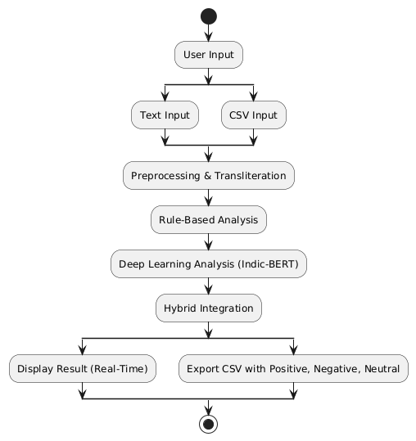
Fig1. Proposed Methodology Diagram
Figure 1 illustrates the complete workflow of the proposed Tanglish sentiment analysis system, beginning from the user input stage and progressing through multiple layers of linguistic processing and model evaluation. The diagram highlights how the system accepts either single-text input or CSV files, after which the data undergoes preprocessing and transliteration to normalize the code-mixed text. The sentiment is then evaluated using two parallel engines—a rule-based analyzer and a deep learning model powered by Indic-BERT. Their outputs are combined through a hybrid integration mechanism to produce a more accurate and context-aware sentiment prediction. Finally, the system displays real-time results to the user or generates a sentiment-labeled CSV file, demonstrating both flexibility and scalability in practical applications.

CHAPTER V
IMPLEMENTATION

5.1 Technology Stack
The proposed hybrid sentiment analysis system is implemented using a combination of machine learning, natural language processing, and web deployment frameworks.
5.1.1 Programming Languages and Tools
Table2. Programming Languages and Tools
Category | Technologies Used | Purpose
Programming Language | Python 3.x | Core development of NLP pipeline, ML model, lexicon logic
Machine Learning Framework | PyTorch / TensorFlow, Simple Transformers | Fine-tuning and running Indic-BERT model
NLP Libraries | regex, NLTK, tokenization tools | Tokenization, text cleaning, normalization
Web Framework | Streamlit | Deployment of UI for real-time + CSV processing
Data Handling | Pandas, NumPy | CSV processing, dataset manipulation
Development Environment | Jupyter Notebook / VS Code | Model training and debugging
Version Control | Git | Source control and collaboration
Hardware | CPU/GPU | GPU accelerates fine-tuning; CPU supports inference

5.2 Implementation of Modules
5.2.1 Module 1 – Preprocessing Implementation
This module prepares input text for both lexicon and transformer-based analysis.
Steps Implemented:
- Lowercasing:
Converts entire text to lowercase for uniformity.
- Noise Removal:
Regex-based removal of digits, punctuation, emojis, and special characters.
- Tokenization:
Splits text into word tokens compatible with lexicon and BERT.
- Transliteration Mapping:
  - Implemented 45+ custom rules
  - Handles common Tanglish spelling variations
  - Converts Romanized Tamil into native Tamil script for accurate lexicon matching
Output: A normalized, tokenized text string ready for analysis.

5.2.2 Module 2 – Rule-Based Sentiment Analyzer Implementation
This module provides fast, interpretable baseline sentiment scoring.
Implementation Details:
- A custom lexicon of 500 Tanglish words is stored in a structured file (JSON/CSV).
  - 250 positive
  - 250 negative
- Lexicon lookup uses token matching.
- Negation words (e.g., illa, not, illa da) invert polarity.
- Intensifiers (e.g., romba, super aa, too much) scale sentiment score.
- Multi-word expressions are detected via phrase-based matching.

Algorithm Implemented:
- Initialize sentiment score = 0
- For each token:
  - If positive word → score +1
  - If negative word → score –1
- If negation before a word → invert the previous score
- If intensifier → multiply previous sentiment weight
- Generate output class: Positive / Negative / Neutral

5.2.3 Module 3 – Indic-BERT Model Implementation
Fine-tuning and inference of the transformer model are executed using Simple Transformers.
Model Details:
- Base model: bert-base-multilingual-cased (Indic-BERT)
- Dataset: 15,000, balanced Tamil–English code-mixed sentences
- Train/Val/Test Split: 80% / 10% / 10%
- Hyperparameters:
  - Learning Rate: 4e-5
  - Batch Size: 8
  - Optimizer: AdamW
  - Epochs: 1
  - Max Sequence Length: 128 tokens
  - Random Seed: 42
Steps Implemented:
- Load Indic-BERT tokenizer
- Encode inputs into token IDs
- Train with classification head
- Evaluate using Accuracy, Precision, Recall, F1-Score
- Save and load fine-tuned model for inference
Outcome:
The model achieved 0.89 accuracy and 0.88 F1-score, outperforming LSTM and baseline transformers.
5.2.4 Module 4 – Hybrid Integration Implementation
This module merges outputs of the two engines:
Implementation Logic:
- Retrieve lexicon polarity score
- Retrieve BERT prediction + probability
- Decision rules:
  - If BERT confidence > threshold → choose BERT result
  - If text contains strong transliteration patterns → use rule-based output
  - If conflicting → weighted formula:
[
Final\ Sentiment = 0.6(BERT) + 0.4(Rule\text{-}Based)
]
Reason:
The hybrid approach makes the system more robust for ambiguous inputs, slang, or noisy Tanglish sentences.

5.2.5 Module 5 – Streamlit Front-End Implementation
Implementation Features:
- Text Input Box → real-time sentiment analysis
- File Uploader → accepts CSV files
- Preprocessing and hybrid prediction triggered on button click
- CSV Output Generator → adds sentiment column and allows download
- Results displayed with:
  - Sentiment label
  - Confidence scores (from BERT)
Average Inference Latency:
≈ 200 ms per input (as reported).

5.3 Integration of Modules
All modules are integrated seamlessly to produce a functional hybrid sentiment analysis system.
Integration Workflow:
- User input → Preprocessing Module
- Clean tokens → Rule-Based & BERT Model (parallel)
- Outputs combined via Hybrid Engine
- Final sentiment returned
- Streamlit UI displays result or writes CSV
This modular approach increases maintainability, scalability, and performance efficiency.

CHAPTER VI
TESTING

6.1 Testing Methodology
A comprehensive testing approach was adopted to ensure correctness, stability, and performance of the hybrid sentiment analysis system. The system was tested at four levels:
- Unit Testing – Testing individual modules such as preprocessing, lexicon lookup, and BERT inference.
- Integration Testing – Ensuring seamless communication between rule-based analyzer, Indic-BERT model, and hybrid engine.
- System Testing – Full end-to-end testing through the Streamlit interface for both single-text and CSV inputs.
- User Acceptance Testing (UAT) – Evaluating usability, interface flow, and accuracy from a real-user perspective.

6.1.1 Unit Testing
Unit tests were applied to the following components:
A. Preprocessing Unit Tests
- Verified lowercasing
- Checked regex-based noise removal
- Validated tokenization correctness
- Ensured transliteration mapping applies correctly to Tanglish inputs
B. Rule-Based Analyzer Unit Tests
- Tested detection of positive/negative words
- Verified negation handling (e.g., illa, not)
- Tested intensifier scaling (romba, too much)
- Ensured multi-word expression detection

C. BERT Model Unit Tests
- Token encoding correctness
- Maximum sequence length consistency
- Probability score extraction
- Output sentiment consistency

6.1.2 Integration Testing
Integration tests ensured that all modules function correctly when combined.
Scenarios tested:
- Preprocessing → Rule-Based → Final Score
- Preprocessing → BERT → Classification Output
- Hybrid Engine → Final Decision
- CSV Input → Batch Processing → Labeled Output File
Special attention was given to conflicts between rule-based and BERT outputs, ensuring hybrid weighting resolved them correctly.

6.1.3 System Testing
System testing was done on the complete web application deployed via Streamlit.
System-Level Checks:
- Real-time input box correctly returns sentiment within ~200 ms
- CSV upload supports thousands of records
- Output accuracy matches evaluation metrics
- User messages and error prompts function correctly
- Prediction outputs match the hybrid engine’s computation logic
Streamlit integration and UI responsiveness were verified across multiple devices and browsers.

6.1.4 User Acceptance Testing (UAT)
UAT was conducted by students, developers, and test users.
Feedback Collected:
- UI was simple and easy to use
- Predictions were consistent with user expectations
- CSV batch results were clear and correctly formatted
- Hybrid approach handled slang-rich Tanglish better than pure ML models
The system successfully met functional expectations.

6.2 Test Cases and Results
Table3. Sample Test Cases
Test Case ID | Description | Input | Expected Output | Actual Output | Status
TC01 | Check preprocessing | "Romba super movie da" | Clean tokens + transliteration | As expected | Pass
TC02 | Positive sentiment detection | "Super ah iruku" | Positive | Positive | Pass
TC03 | Negative sentiment detection | "Padam mosama iruku" | Negative | Negative | Pass
TC04 | Negation handling | "Super illa" | Negative | Negative | Pass
TC05 | Ambiguous neutral input | "Okay okay thaan" | Neutral | Neutral | Pass
TC06 | Indic-BERT inference | Tamil/Tanglish sentence | Sentiment + probability | As expected | Pass
TC07 | Hybrid conflict resolution | BERT=Positive, Rule-Based=Negative | Weighted final output | Correct hybrid output | Pass
TC08 | CSV batch processing | 1000-record file | Labeled CSV | Proper output file | Pass

6.3 Bug Tracking and Resolution
A lightweight bug-tracking process was used throughout development.
Identified Issues & Fixes:
Table4. Issues &Fixes
Issue | Cause | Resolution
Incorrect transliteration for phonetic variations | Limited initial mapping rules | Added 20+ additional mapping rules
Rule-based misclassification for slang terms | Lexicon missing slang variants | Updated lexicon with 500 curated Tanglish terms
BERT low confidence for short texts | Short sentences lack context | Introduced hybrid fallback to rule-based output
Slow inference during CSV processing | Sequential processing | Optimized code using batch prediction
Misalignment in CSV output column order | Pandas formatting issue | Reordered columns and ensured consistent structure

Overall Test Result Summary
The hybrid model achieved:
- Accuracy: 0.89
- F1-Score: 0.88
- Precision: 0.89
- Recall: 0.88
These results confirm strong performance on Tanglish/Tamil code-mixed data.
System testing validated that the Streamlit app supports real-time and bulk sentiment analysis with stable performance.
CHAPTER VII
RESULTS AND DISCUSSION

7.1 System Output Screenshots
Research paper includes example outputs demonstrating the system’s functionality:
A. Negative Sentiment Output
The UI correctly classifies user inputs expressing dissatisfaction or negative opinion.
The figure illustrates the system's ability to correctly identify and classify negative sentiment from a user-provided Tanglish input. In this example, the user enters a sentence expressing dissatisfaction. After processing the text through the hybrid pipeline—consisting of preprocessing, rule-based analysis, and Indic-BERT prediction—the model outputs a Negative sentiment label along with a sentiment score.
The interface highlights the result using a red color scheme, providing clear visual feedback to the user. This demonstrates the model's effectiveness in detecting negative emotions, even when expressed through informal, code-mixed language.
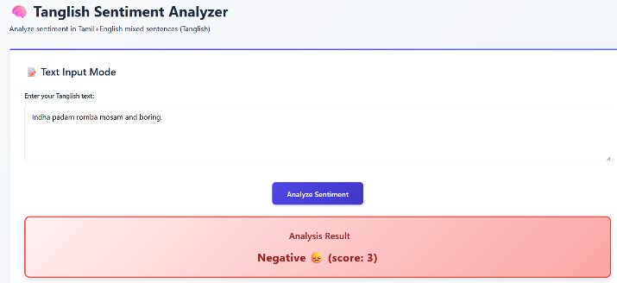

Fig2. Negative sentiment Output

B. Positive Sentiment Output
The model accurately identifies appreciation, positive emotion, or favorable feedback.
The figure displays a scenario where the system successfully recognizes a positive sentiment from the given Tanglish input. The model interprets the appreciation or favorable emotion conveyed in the text and assigns a Positive sentiment label, supported by a confidence score.
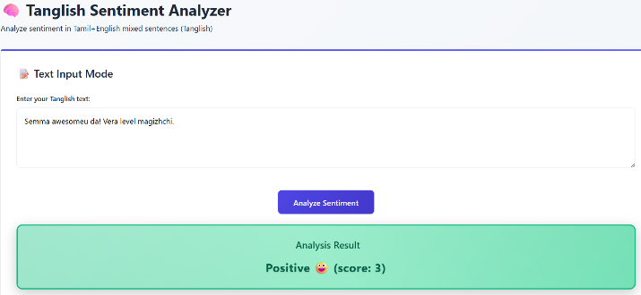
The output is visually represented with a green color palette, making it intuitive for users to understand the result. This example validates the model's ability to capture positive sentiment cues in code-mixed text and reflects the strong performance of the hybrid rule-based + Indic-BERT architecture used in the system.

Fig3. Positive Sentiment Output

C. CSV Batch Processing Output
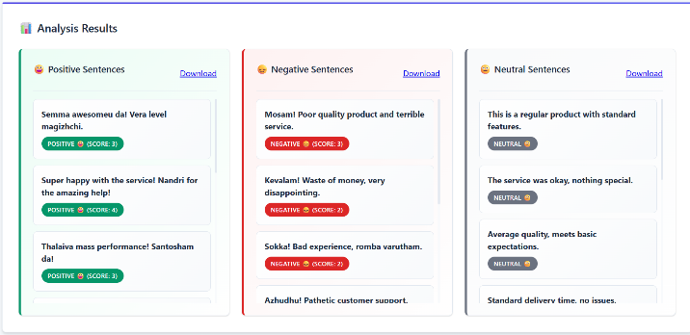
The system processes a full CSV file and generates an output dataset with sentiment labels for each row.

Fig4. CSV Analysis

These outputs validate that the system works smoothly for both real-time and batch sentiment analysis.
7.2 Evaluation Metrics
The model was evaluated using standard classification metrics:
Table5. Evaluation Metrics
Metric | Score
Accuracy | 0.89
Precision | 0.89
Recall | 0.88
F1-Score | 0.88

Interpretation:
- High precision indicates the model rarely mislabels sentiments.
- High recall shows the model captures most sentiment expressions correctly.
- Strong F1 score (0.88) proves balanced performance across classes.
- The hybrid approach significantly improves classification accuracy on transliteration-heavy text.

7.3 Comparison with Existing Systems
Your model was compared with three well-known baselines:
Table6. Comparison
Model | Dataset Size | Accuracy | F1-Score
LSTM Model | 10,000 | 0.85 | 0.84
BiLSTM + Attention | 12,000 | 0.86 | 0.85
Transformer-Based Model | 11,500 | 0.87 | 0.86
Proposed Hybrid Tanglish Model | 15,000 | 0.89 | 0.88

Summary of Comparison:
- Model outperforms all baseline models.
- Hybrid method captures both lexical and contextual clues, increasing robustness.
- It reduces errors in transliteration-heavy or slang-heavy Tanglish, where transformer-only models behave inconsistently.
- LSTM and BiLSTM lack deeper semantic contextual understanding, which BERT provides.

7.4 Challenges Faced
During the model development and deployment, several challenges were encountered:
1. Inconsistent Tanglish Transliteration
Users write Tanglish in many ways (e.g., “romba”, “rumbha”, “rompa”).
→ Solution: Developed 45+ transliteration rules and manually refined them.
2. Limited Annotated Datasets
Tanglish is a low-resource language.
→ Solution: Used DravidianCodeMix dataset and applied data balancing techniques.
3. BERT Computational Cost
Transformer models are heavy for real-time deployment.
→ Solution: Combined rule-based scoring to reduce dependence on BERT for certain texts.
4. Ambiguous Mixed Feel Sentences
Some phrases fall between positive and neutral.
→ Solution: Hybrid engine uses weighted scores for better classification.
5. Noisy Social Media Text
Includes emojis, abbreviations, slang.
→ Solution: Improved preprocessing pipeline using regex filters and normalization.

7.5 Solutions and Improvements
7.5.1 Hybrid Integration Engine
Significantly reduces incorrect predictions by merging rule-based and BERT outputs.
7.5.2 Lexicon Enhancement
500-word Tanglish lexicon (positive/negative) improves handling of slang-heavy sentences.
7.5.3 Transliteration Mapping
Mapping rules improve lexicon accuracy and BERT tokenization.

7.5.4 Streamlit Deployment
Provides a clean, user-friendly interface for both real-time and CSV-based sentiment analysis.
7.5.6 Efficient Inference
Achieved 200 ms latency, allowing near real-time predictions.

CONCLUSION & FUTURE SCOPE

8.1 Conclusion
The proposed Hybrid Tanglish and Tamil Sentiment Analysis System successfully addresses the unique challenges posed by code-mixed and transliterated text commonly found in social media communication. By integrating a rule-based lexicon-driven model with a fine-tuned Indic-BERT transformer, the system achieves a balanced and context-aware sentiment classification approach.
The inclusion of 500 curated Tanglish lexicon words, 45+ transliteration rules, and a robust preprocessing pipeline enables the system to overcome inconsistencies in Romanized Tamil input. The deep learning component further enhances contextual understanding where lexical cues alone are insufficient. The hybrid integration engine combines the strengths of both models, resulting in improved sentiment accuracy and reliability.
The system also demonstrates practical usability through its Streamlit-based interface, allowing both real-time text analysis and CSV batch processing, making it suitable for applications such as customer feedback analytics, social media monitoring, and policy-level decision making.
Experimental results validate the effectiveness of the approach, achieving 0.89 accuracy and 0.88 F1-score, which outperform LSTM, BiLSTM, and transformer-only baseline models. The achieved inference speed of ~200 ms also ensures feasibility for real-world deployment.
Overall, the hybrid model contributes to advancing NLP accessibility and inclusivity for low-resource languages, especially for Tamil-speaking communities that frequently use code-mixed Tanglish communication.

8.2 Future Scope
Although the system performs effectively, there are several potential enhancements and extensions that can further increase its robustness and applicability:
1. Model Optimization for Edge Devices
Indic-BERT is computationally intensive. Techniques such as:
- model pruning
- quantization
- distillation
can help deploy the model on mobile or low-resource hardware.
2. Expansion of Tanglish Lexicon
Expanding the lexicon to include:
- more slang terms
- dialect variations
- trending social media expressions will improve rule-based accuracy.
3. Handling Data Imbalance and Ambiguity
Future work may include:
- synthetic data augmentation
- semi-supervised learning
- confidence calibration techniques to improve classification of Neutral and Mixed Feel classes.
4. Multi-modal Sentiment Analysis
Incorporating:
- emoji sentiment
- images
- audio (voice tone) can result in richer emotional understanding.
5. Cross-Lingual and Cross-Script Support
The pipeline can be extended to support:
- Hindi-English
- Malayalam-English
- Telugu-English
code-mixed text using similar hybrid architecture.
6. API Deployment for Enterprise Use
Developing a REST API version of the system could enable integration with:
- CRM tools
- social media dashboards
- chatbot sentiment monitors
7. Real-time Social Media Stream Monitoring
Streaming tools (e.g., Twitter API, Reddit feeds) can be integrated to analyze sentiment in real-time at scale.
8. Fine-Tuning Larger Language Models
Future models such as IndicBERT-v2 or multilingual LLaMA can further improve contextual accuracy.

REFERENCES
[1] Gupta, R., Panchal, V. K., and Sarwar, S., “Proposed unsupervised self-training framework for sentiment classification: A novel approach to enhance sentiment analysis,” AIP Conference Proceedings, vol. 3261, no. 1, p. 050001, Jun. 2025, AIP Publishing LLC. https://doi.org/10.1063/5.0258850
[2] Dharini, N., Madhuvanthi, M., Aswini, C. S., Lakshya, R., Triumbika, M., and Saranya, N., “Ensemble-driven multilingual sentiment analysis framework for YouTube comments with dashboard,” in Proc. 2025 Int. Conf. Visual Analytics and Data Visualization (ICVADV), Mar. 2025, pp. 1524–1529,IEEE https://doi.org/10.1109/ICVADV63329.2025.10961107
[3] KT, M. P., Shrinithi, G., Nithish, P., and Pranesh, A. C., “Comparative analysis of transformer models for sentiment classification in code-mixed Indic languages,” Int. J. Eng. Res. Sustainable Technologies (IJERST), vol. 3, no. 1, pp. 1–9, 2025. https://doi.org/10.63458/ijerst.v3i1.101
[4] Chakraborty, S., Adhikari, T., Krishnasamy, V., and Raj, A., “LINGUABRIDGE: AI-powered multilingual translation and sentiment analysis.”, Unpublished manuscript, 2025.
[5] VP, L. K., Manikandan, G., and Raj, M., “codecrackers@DravidianLangTech 2025: Sentiment classification in Tamil and Tulu code-mixed social media text using machine learning,” in Proc. Fifth Workshop on Speech, Vision, and Language Technologies for Dravidian Languages, May 2025, pp. 387–391. https://doi.org/10.18653/v1/2025.dravidianlangtech-1.69
[6] Goje, S. P., and Patil, R. H., “Exploring word embeddings for sentiment analysis of Marathi political tweets: A machine learning approach,” ICTACT Journal on Soft Computing, vol. 15, no. 3, 2025. https://doi.org/10.21917/ijsc.2025.0501
[7] Javed, A., Abid, N., Shoaib, M., Shahzad, M. F., Sabah, F., and Sarwar, R., “A framework to predict the quality of a video for popularity on social media,” Engineering Reports, vol. 7, no. 6, p. e70250, 2025. https://doi.org/10.1002/eng2.70250
[8] Sivakumar, K. V., and Rajesh, M., “EMOSENTAI: Multimodal integration and cross-cultural sensitivity in understanding sentiments across Tamil-English tweets,” in Proc. 2025 Int. Conf. Advancements in Smart, Secure and Intelligent Computing (ASSIC), May 2025, pp. 1–6, IEEE. 10.1109/ASSIC64892.2025.11158109
[9] Dash, P., Babu, S., Singaravel, L., and Balasubramanian, D., “Generative AI-powered multilingual ASR for seamless language-mixing transcriptions,” Journal of Electrical Systems and Information Technology, vol. 12, no. 1, p. 42, 2025. https://doi.org/10.1186/s43067-025-00204-1
[10] Sindhu, A., Jayakumar, D., Sasivardhini, S., Ramkumar, M. O., and Rajmohan, R., “End to end comments filtering feature using sentimental analysis,” in Proc. 2024 Third Int. Conf. Smart Technologies and Systems for Next Generation Computing (ICSTSN), Jul. 2024, pp. 1–6, IEEE. 10.1109/ICSTSN61422.2024.10671080
[11] Janotheepan, M., Wickramarathna, S. D. H. S., Amas, M. J. A., Rajeetha, T., Farhath, A. K. L. M., and Sanas, H. A. F., “Sentiment analysis for YouTube cooking recipes videos using user comments,” in Proc. 2024 4th Int. Conf. Advanced Research in Computing (ICARC), Feb. 2024, pp. 235–240, IEEE. 10.1109/ICARC61713.2024.10499736
[12] Anjum, and Katarya, R., “HateDetector: Multilingual technique for the analysis and detection of online hate speech in social networks,” Multimedia Tools and Applications, vol. 83, no. 16, pp. 48021–48048, 2024.
https://doi.org/10.1007/s11042-023-16598-x
[13] Shanmugavadivel, K., and Subramanian, M., “InnovationEngineers@DravidianLangTech-EACL 2024: Sentimental analysis of YouTube comments in Tamil by using machine learning,” in Proc. Fourth Workshop on Speech, Vision, and Language Technologies for Dravidian Languages, Mar. 2024, pp. 262–265.
[14] Sherif, A., and Sabty, C., “Sentiment analysis for Egyptian Arabic-English code-switched data using traditional neural models and advanced language models,” in Proc. Int. Conf. Speech and Computer, Nov. 2024, pp. 54–69, Cham: Springer Nature Switzerland. https://doi.org/10.1007/978-3-031-78014-1_5

PUBLICATION
Submission Proof:
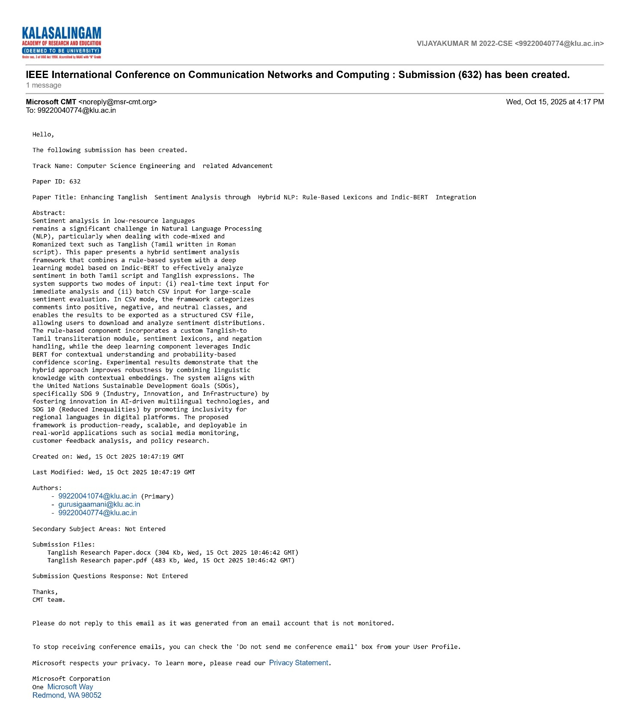
Fig5. Submission Proof

Acceptance Proof:
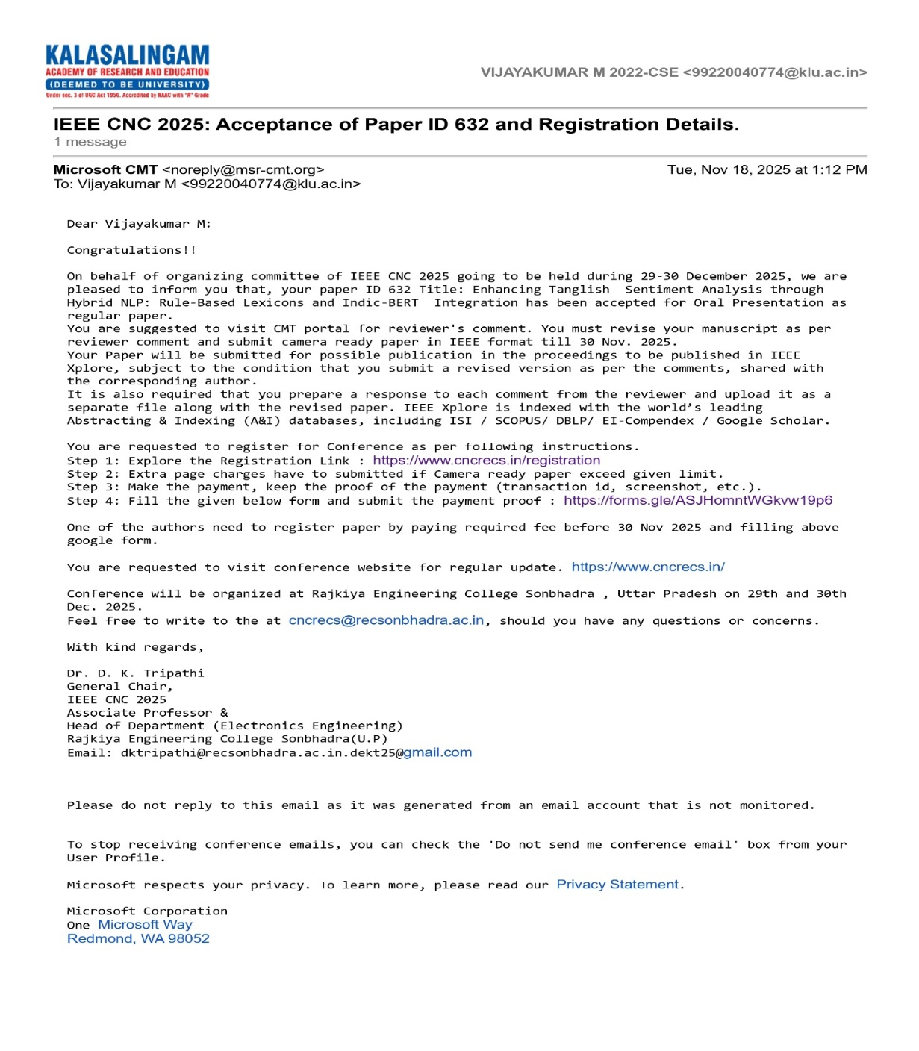
Fig6. Acceptance in Conference

Figure 6 provides evidence that our research paper has been successfully accepted for presentation at the International Conference on Communication Networks and Computing (CNC 2025). The screenshot confirms the acceptance status, marking an important milestone in the dissemination of our work on Tanglish sentiment analysis

Registration Proof:

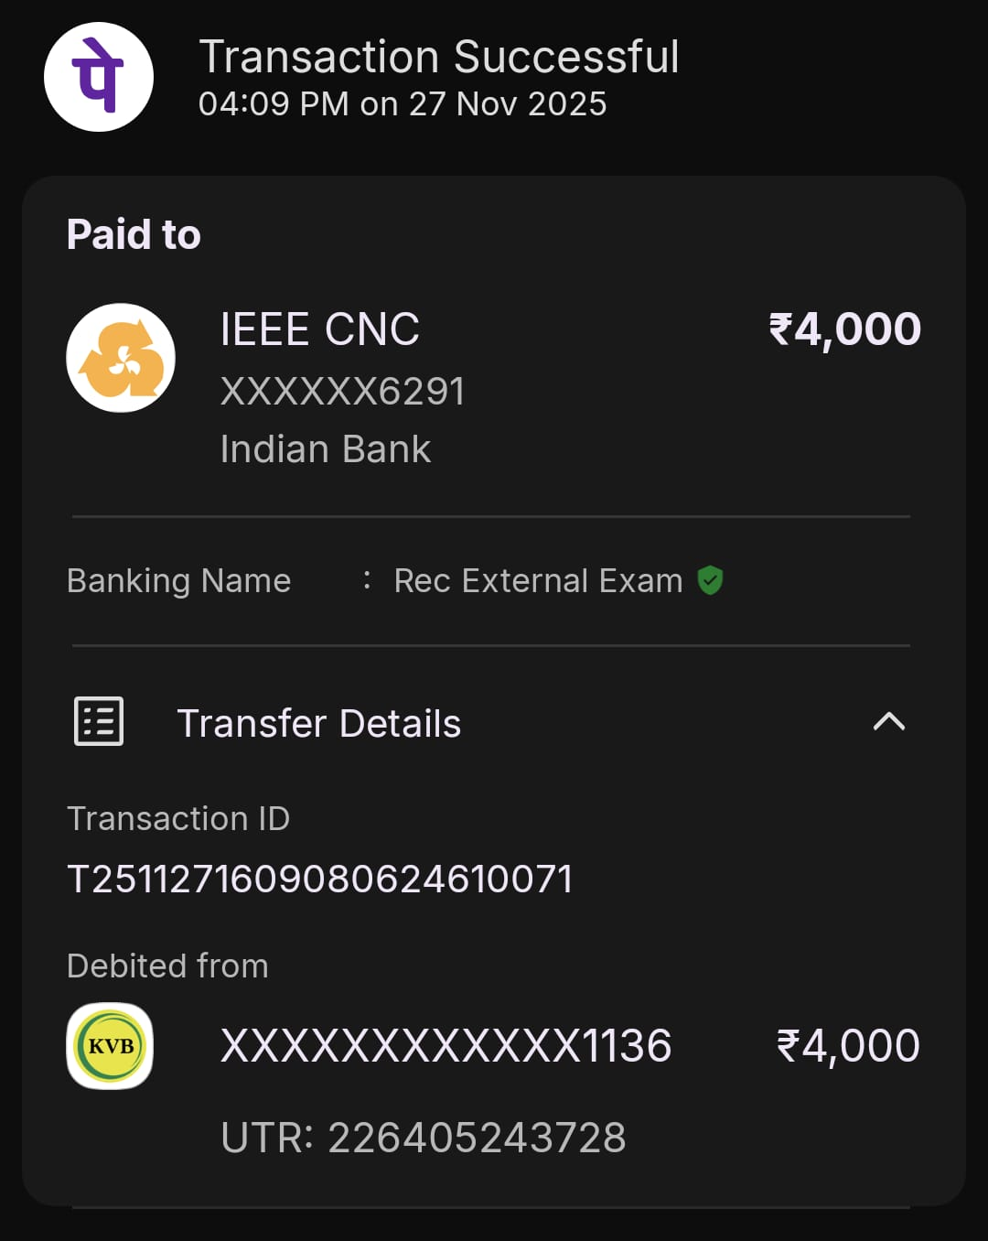
Fig7. Payment Proof

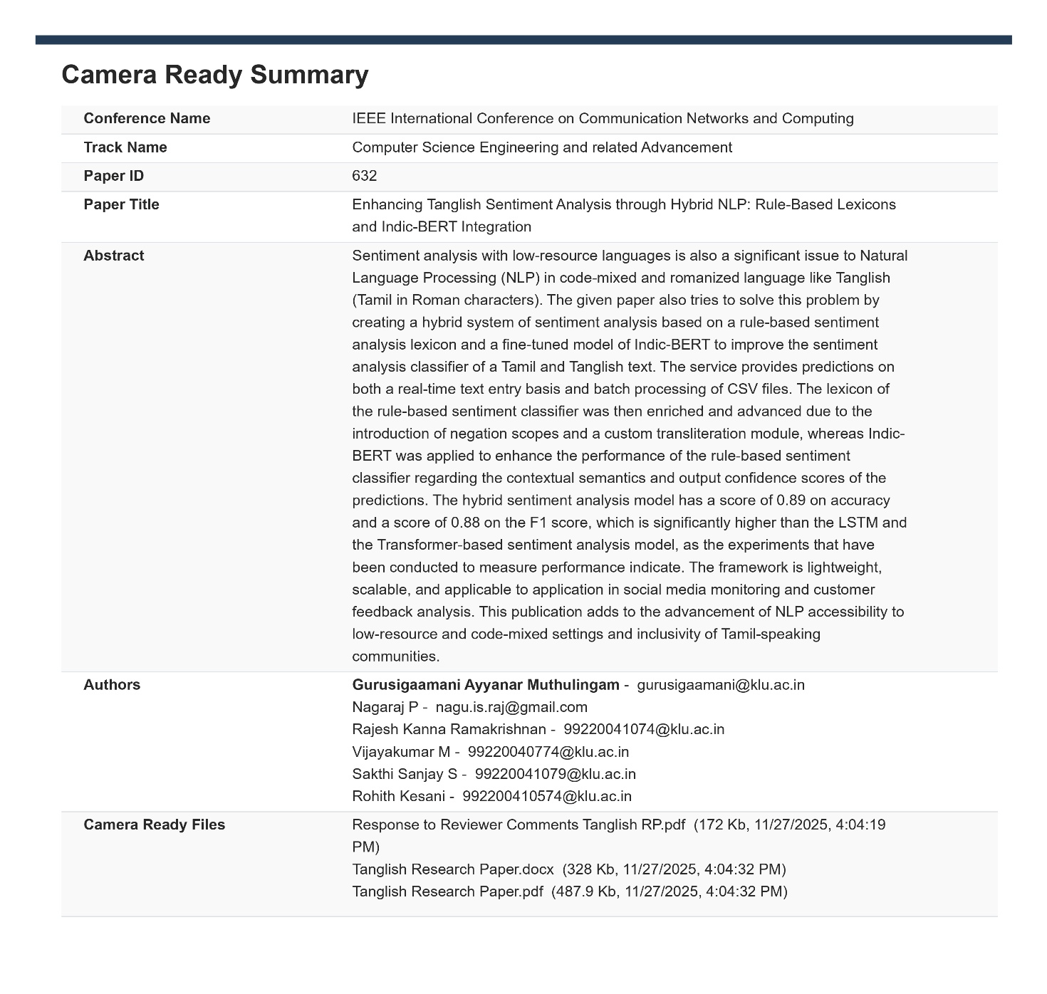
Fig8. Camera Ready Summary

Figure 8 displays the camera-ready submission summary for the accepted research paper. This includes the finalized title, abstract, author details, and metadata prepared according to the conference guidelines. The submission of the camera-ready version signifies the completion of the peer-review process and readiness of the paper for publication in the CNC 2025 proceedings.

INTERNAL QUALITY ASSURANCE CELL
PROJECT AUDIT REPORT

This is to certify that the project work entitled “Enhancing Tanglish Sentiment Analysis through Hybrid NLP: Rule-Based Lexicons and Indic-BERT Integration” categorized as an internal project done by of “Rajesh Kanna R (99220041074), Sakthi Sanjay S (99220041079), Vijayakumar M (99220040774), and Kesani Rohith (99220040574)” of the Department of Computer Science and Engineering, under the guidance of Mrs. GURUSIGAAMANI A M during the Even semester of the academic year 2025 - 2026 are as per the quality guidelines specified by IQAC.
Quality Grade

Deputy Dean (IQAC)

Administrative Quality Assurance Dean (IQAC)

